**Project 2**

**Question 1**

1. Reconstructed image using SART algorithm



1. The plot of root-mean-square error (RMSE) of SART algorithm

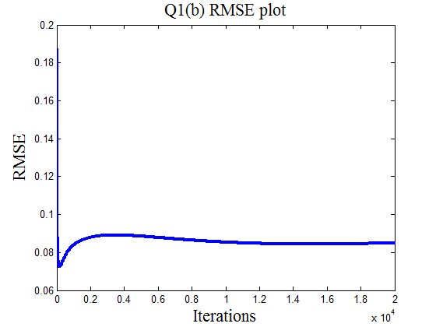

1. The superimposed plot of RMSE. The SART algorithm converges to the accurate solution faster that ART algorithm, because the correction terms in SART are simultaneously applied for all the rays in one projection; this is in contrast with the ray-by-ray updates in ART.

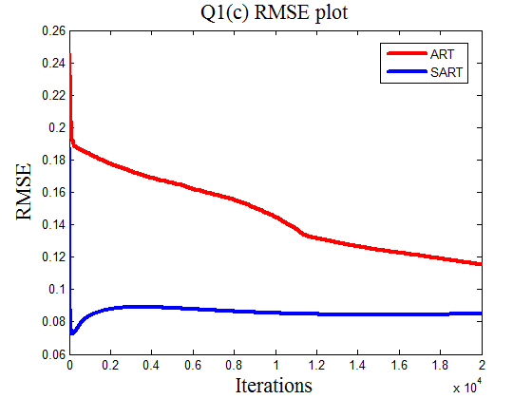

1. Reconstructed image with Gaussian white noise in g1



The plot of RMSE

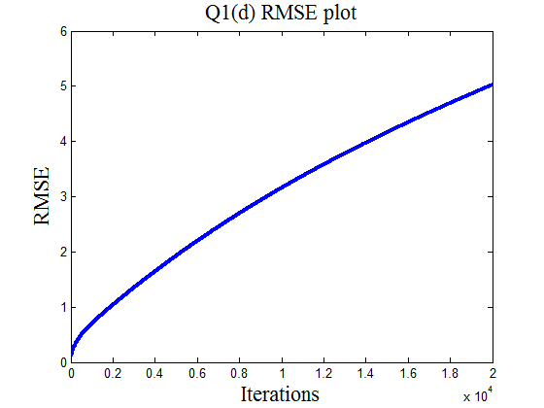

**Question 2**

1. Reconstructed image using non-negative ART

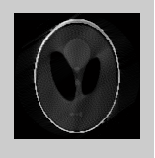

1. The RMSE plot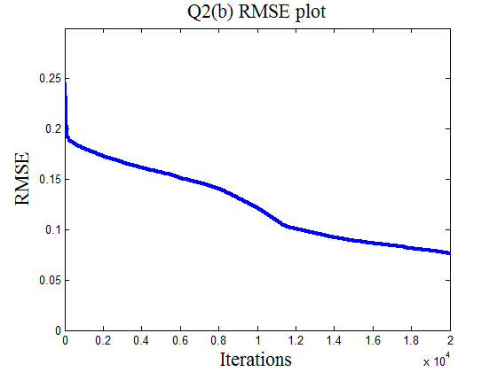
2. The superimposed plot of RMSE. The non-negative ART (NN-ART) algorithm converges faster than the ART algorithm, because NN-ART reduces the size of the Hilbert space in which the iteration algorithm searches its solution.

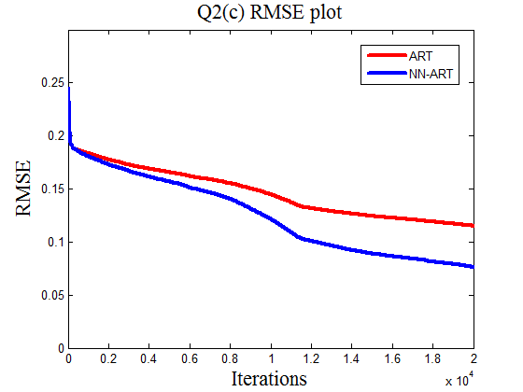

1. The reconstructed image using ART algorithm

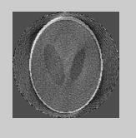

The reconstructed image using NN-ART algorithm

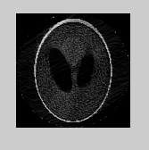

The pixels in the second image do not have negative values, because we set the values of solved negative pixels equal to 0.